[Pages 1 and 2: Instructions for facilitators; Pages 3 and 4: Instructions for participants]
Personal Digital Archiving Train-the-Trainer Workshop
Activity

July 31, 2014 - Society of Georgia Archivists, Georgia Library Association, ARMA Atlanta

Outline of activity session (60 minutes):
- Intro and explanation (5 minutes)
  - Distribute instruction sheets and USB drives containing the Find the Person in the Personal Digital Archive: Murder Mystery Edition dataset to small breakout groups (3-5 people)
- Find the Person in the Personal Digital Archive: Murder Mystery Edition! (25 minutes)
- Reflection and Discussion about Personal Digital Archiving (10 minutes)
- Group Sharing and Discussion (10 minutes)
  - Facilitate large group discussion

Sources for the files adapted for use in the Find the Person in the Personal Digital Archive: Murder Mystery Edition dataset (all of the files were licensed by their creators for reuse):
https://flic.kr/p/c2qhc
https://flic.kr/p/8YUZW9
https://flic.kr/p/4K7nj
https://flic.kr/p/eBtfkE
https://flic.kr/p/ny9X8G
https://flic.kr/p/oqLrSt
https://flic.kr/p/a5kmk6
https://flic.kr/p/7GN3d4
https://flic.kr/p/dgYKGS
https://flic.kr/p/p5kGE
https://flic.kr/p/6Xn5fK
https://flic.kr/p/iQQ23
https://flic.kr/p/8UyU3D
https://flic.kr/p/8Hhywk
https://flic.kr/p/bqFziU
https://flic.kr/p/d2UJhY
https://flic.kr/p/jqaM5Z
https://flic.kr/p/AwPyW
https://flic.kr/p/iJRSNb
https://flic.kr/p/ge3285
https://flic.kr/p/nWRTDD
https://flic.kr/p/odmCwK
http://upload.wikimedia.org/wikipedia/commons/2/20/Family_portrait.jpg
https://flic.kr/p/5RMzxu
http://commons.wikimedia.org/wiki/File%3ABaby.jpg
http://commons.wikimedia.org/wiki/File%3ATouristes.JPG
http://commons.wikimedia.org/wiki/File%3AJournalist_desk.jpg
http://commons.wikimedia.org/wiki/File%3AAfghan_journalists_(6285350215).jpg
http://commons.wikimedia.org/wiki/File%3ADavid_Houser_House.jpg
http://commons.wikimedia.org/wiki/File%3AHotel_room_view%2C_Berlin%2C_Germany_(5981561021).jpg
http://commons.wikimedia.org/wiki/File%3AView_from_hotel_room_(8436539281).jpg
http://commons.wikimedia.org/wiki/File%3AMorning_view_from_hotel_room_(1622140061).jpg
http://commons.wikimedia.org/wiki/File%3AView_from_the_hotel_room_(8437649790).jpg
https://flic.kr/p/h8xiKJ
https://flic.kr/p/bkrLk
https://flic.kr/p/c5mPvL
https://flic.kr/p/7fv7Vw
https://flic.kr/p/4PbNCq
https://flic.kr/p/hWeyiV
http://commons.wikimedia.org/wiki/File%3ARussian_Embassy_US.jpg
http://commons.wikimedia.org/wiki/File%3ASecretary_Kerry_Walks_with_Ambassador_McFaul_and_his_Family.jpg
http://commons.wikimedia.org/wiki/File%3AMoscow%2C_Kamennaya_Sloboda_Lane.jpg
http://commons.wikimedia.org/wiki/File%3AMoscow%2C_Vtorov_Mansion.jpg
http://commons.wikimedia.org/wiki/File%3APUW_Terminal.JPG
http://commons.wikimedia.org/wiki/File%3AEdward_Snowden_2013-10-9_(1).jpg
http://commons.wikimedia.org/wiki/File%3A2013-12-30_30C3_2840.JPG
http://commons.wikimedia.org/wiki/File%3AGreenwald_and_Miranda_at_Congress.jpg
http://commons.wikimedia.org/wiki/File%3ALaura_Poitras_-_PopTech_2010_-_Camden%2C_Maine.jpg
http://commons.wikimedia.org/wiki/File%3AMoscow_PetrovskyPalace1p.jpg
http://commons.wikimedia.org/wiki/File%3AMoscow_dogs.jpg
http://commons.wikimedia.org/wiki/File%3AMoscow_FenceAlexandrovskyGarden.JPG
https://github.com/openplanets/format-corpus
http://s3.documentcloud.org/documents/1227228/2013-watchlist-guidance.pdf via http://interc.pt/1r8CooO

Personal Digital Archiving Train-the-Trainer Workshop
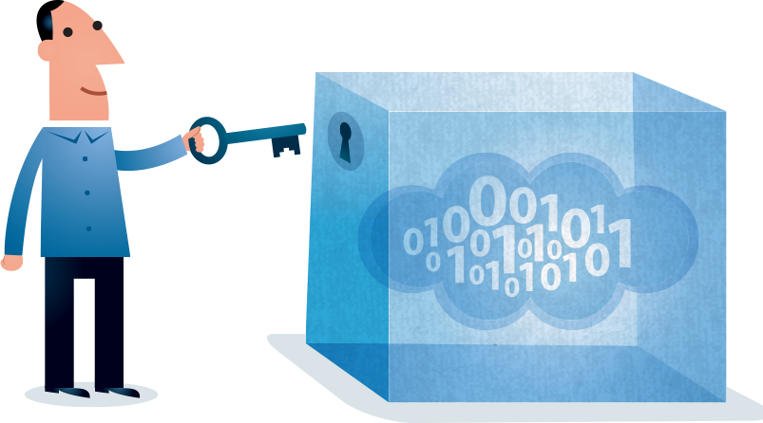
Activity

July 31, 2014 - Society of Georgia Archivists,
Georgia Library Association, ARMA Atlanta

Find the Person in the Personal Digital Archive: Murder Mystery Edition! (25 minutes)
Time to channel Agatha Christie, Sherlock Holmes, and your favorite character from Clue. Imagine you’ve been given a USB drive that was found at the scene of a murder, and it is believed to contain a personal digital archive that could reveal clues about the crime and the identity of the victim. (Best practice would not be to explore the contents of an orphaned USB drive without knowing where it came from, but in this case, we can assure you that the drive and its contents are safe.) Plug the drive into a laptop belonging to one of your group members and explore the digital records. As a group, discuss and answer the following:

- How would you describe the contents (files, directories) of the archive, in a quick inventory?

- Briefly, how did the creator of the archive name and arrange the files?

- Based on your exploration of the archive, who was the person to whom the USB drive belonged? Look for clues and make inferences about the person’s occupation, interests, organizational habits, etc. In one sentence, how would you characterize the person? (You can even take a guess at his/her name, if you’d like.)

- Which of the digital records might be important to preserve for the long term? Which of the records might not be important to preserve for the long term?

- Which of the directories or files might contain private information?

- Do you notice or have you encountered any potential preservation problems? (Files that can’t be opened, for example?)

- How do the features of the archive (such as filenames, organization scheme, file format, etc.) make some of the records easy to understand and some of them impossible to understand? In your opinion, what examples of good and bad personal digital archiving practice do you see?

- Based on your observations and understanding of the creator, how would you rename and rearrange the files into an order that would support the long-term preservation of the files? Imagine organizing them in a way that would help the creator’s children make sense of the files in the future. Would you change how or where they are stored? Explain your decisions.
Small Group Reflection and Discussion about Personal Digital Archiving (10 minutes)
As a group, discuss the following:
- In your experience or opinion, what do you think is the most challenging aspect of archiving your own personal digital records?

- Has this workshop inspired you to consider your personal digital records in a new way? Has it inspired you to make a change about how you manage your records? Has it brought up new questions and unresolved challenges?

- Some information professionals predict that in the future, creators will bear more of the burden for preserving their own records themselves, rather than relying on archives, libraries, and institutions to preserve their records. Do you agree with this prediction? If so, how do you think information professionals should prepare for this kind of future? How do you think information professionals could partner with and train creators to preserve records?

Large Group Sharing and Discussion (10 minutes)
The entire workshop class will gather together to share insights.
- What themes and insights did your group discover during the Find the Person in the Personal Digital Archive challenge? Who do you think the creator is? What did you discover about their archiving practices?

- What themes, insights, and questions arose during your group reflection and discussion about personal digital archiving?

